Auto Scaling
1 . Frist we want to open the console to create instance

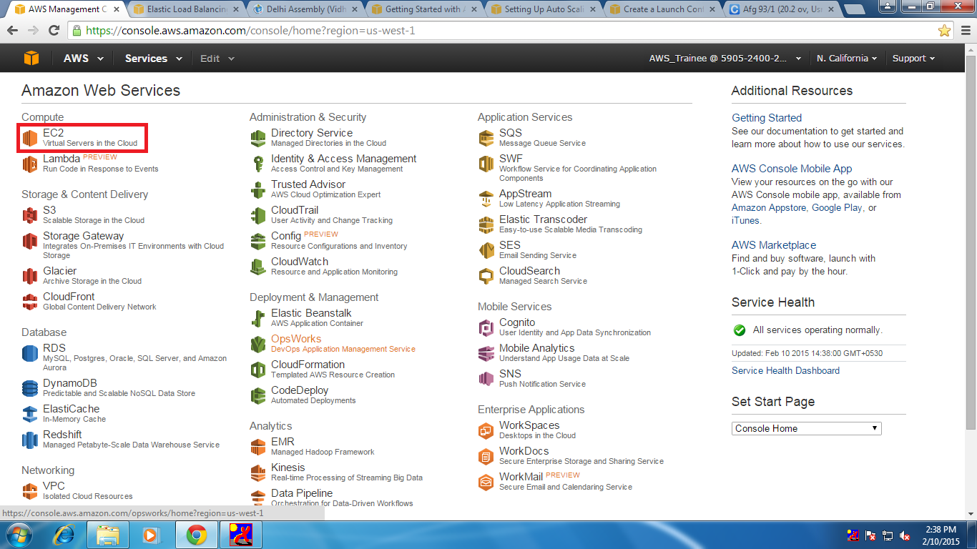

2. In this page we want to click on launch instance 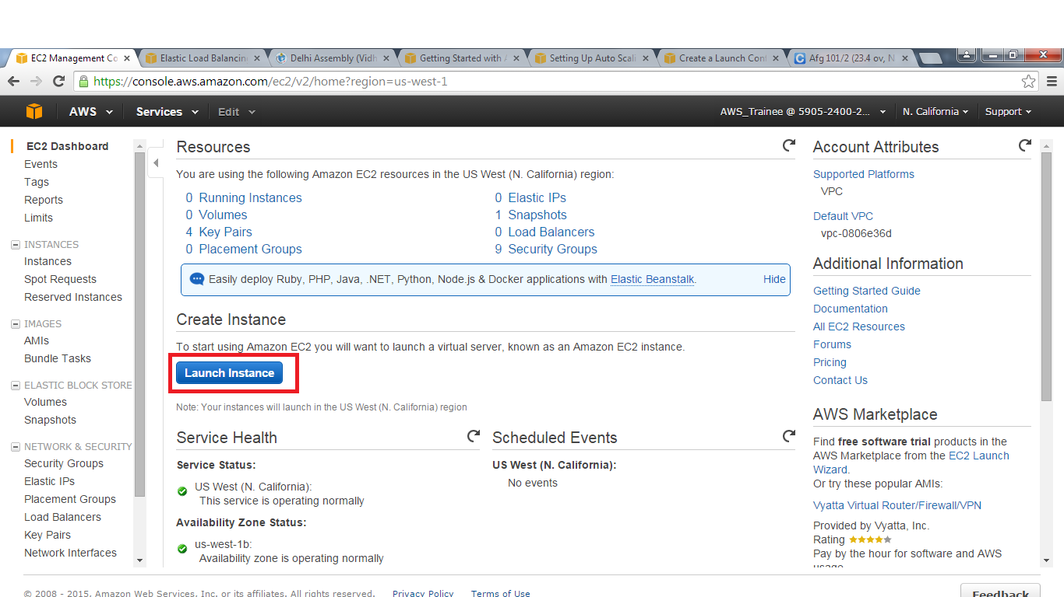

3. After creating the instance we have to create a image of the instance

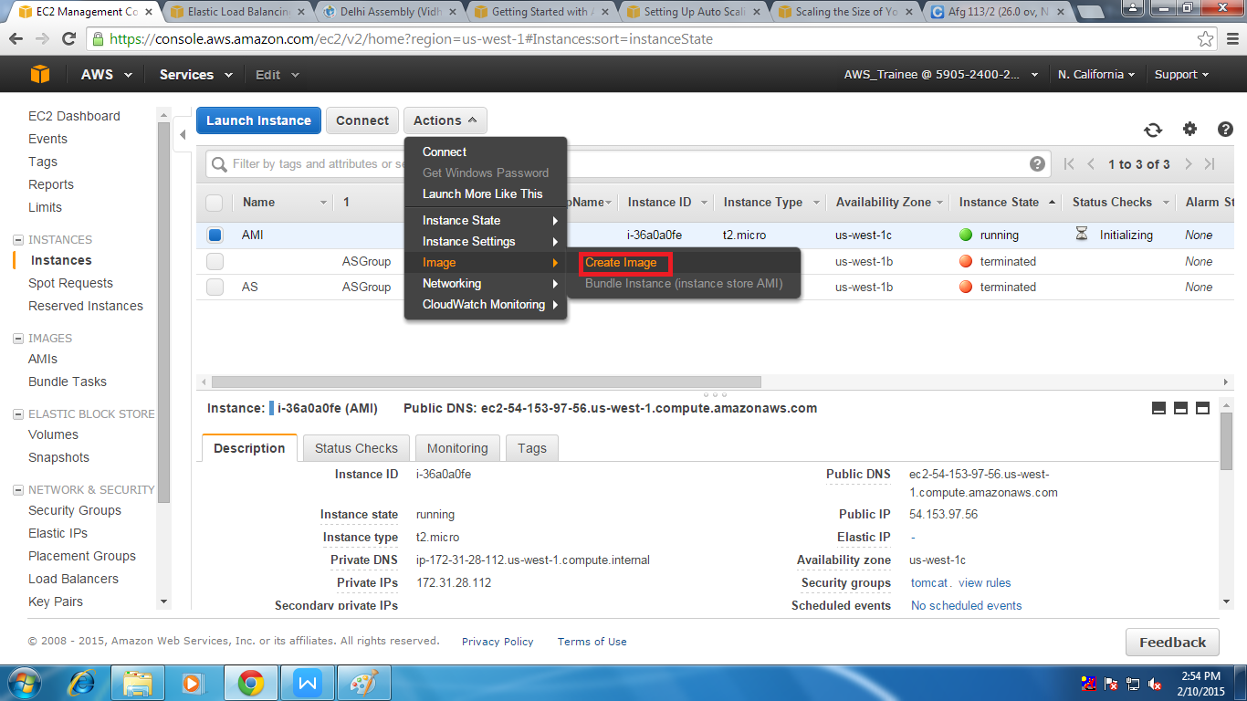

4. After selecting the option create image than we will find a page where we have to assign a name to that image
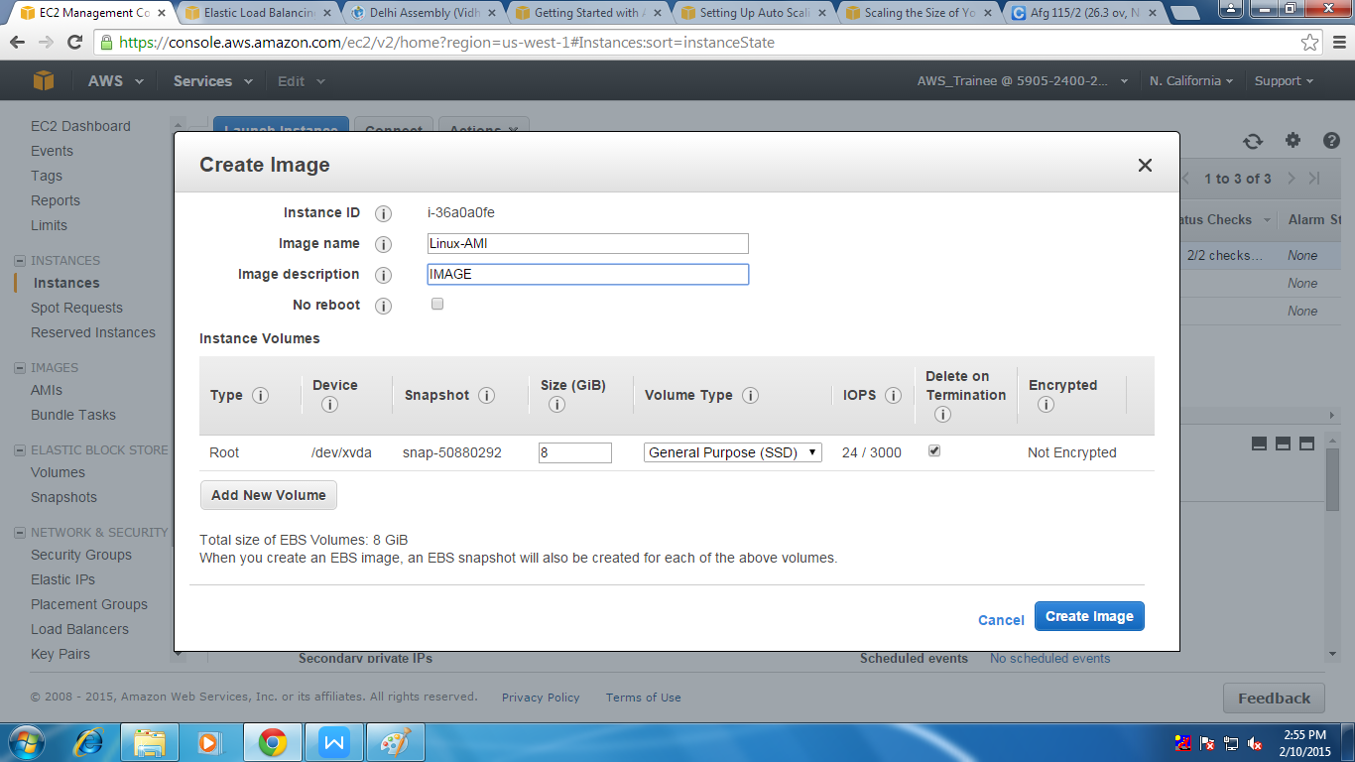

5. Than we have to go to navigation plane of the ec2 Dashboard and select Launch Configuration
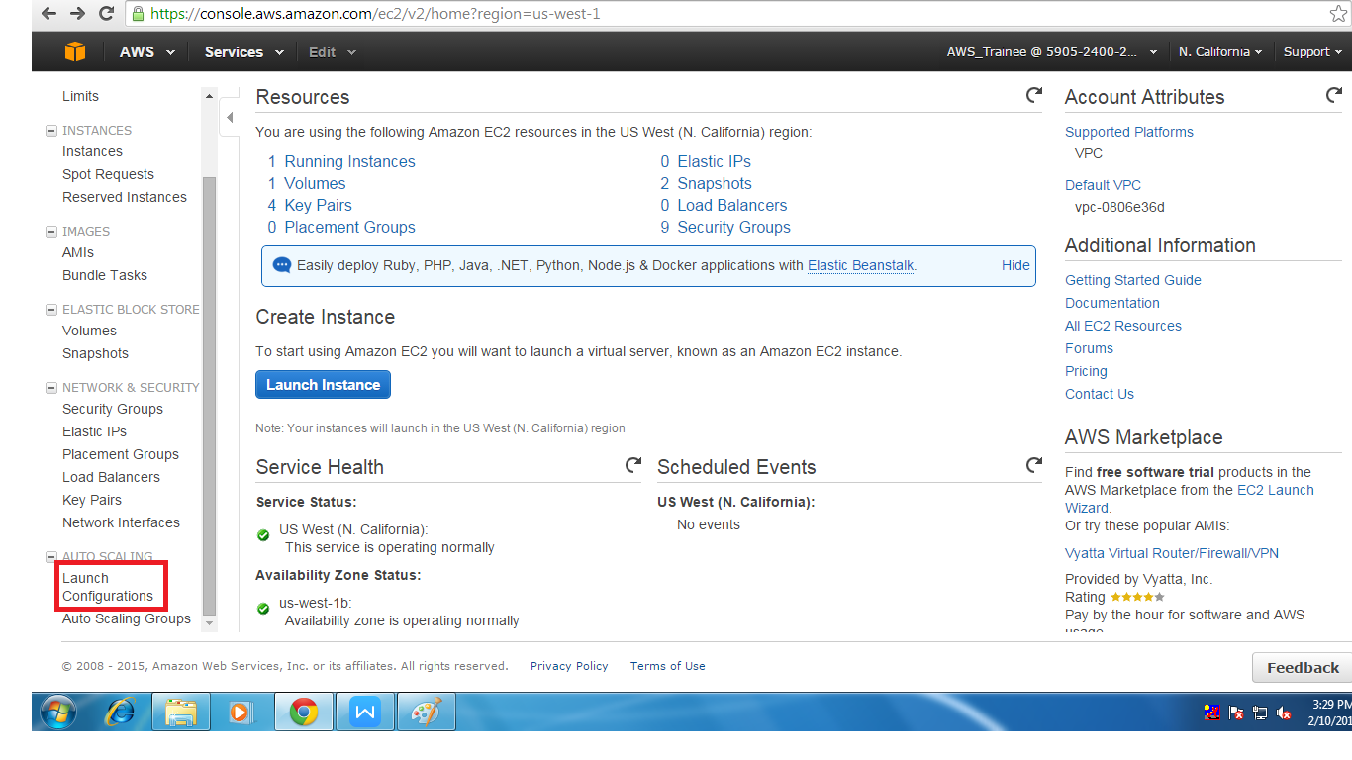
6. Than you have to select create auto scaling group
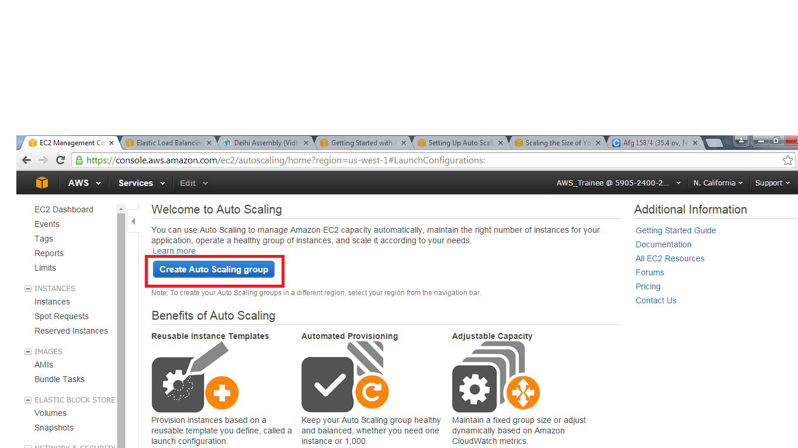

7. After that we will find a page where we have to create launch configuration

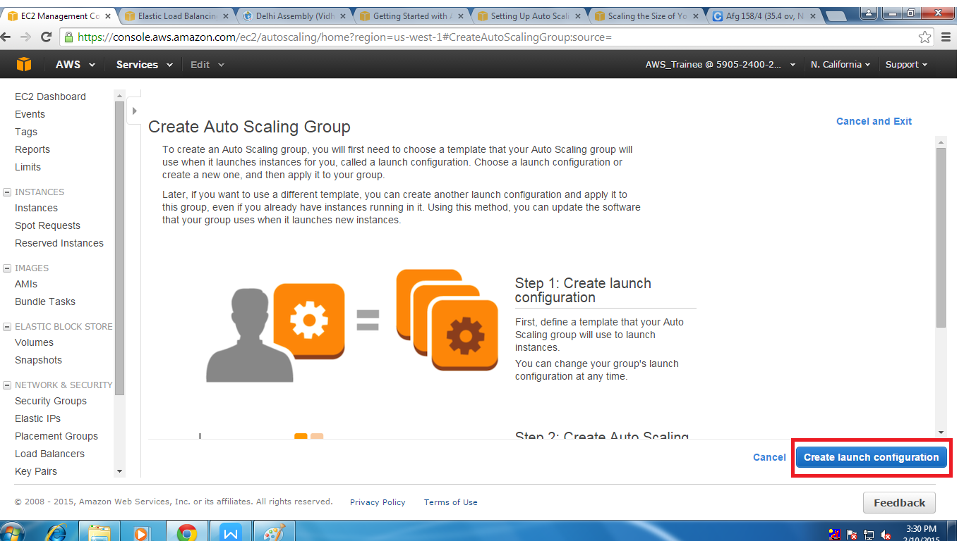

8 . In this we have select the AMI which we want use to create the instance add the instance in auto scaling group
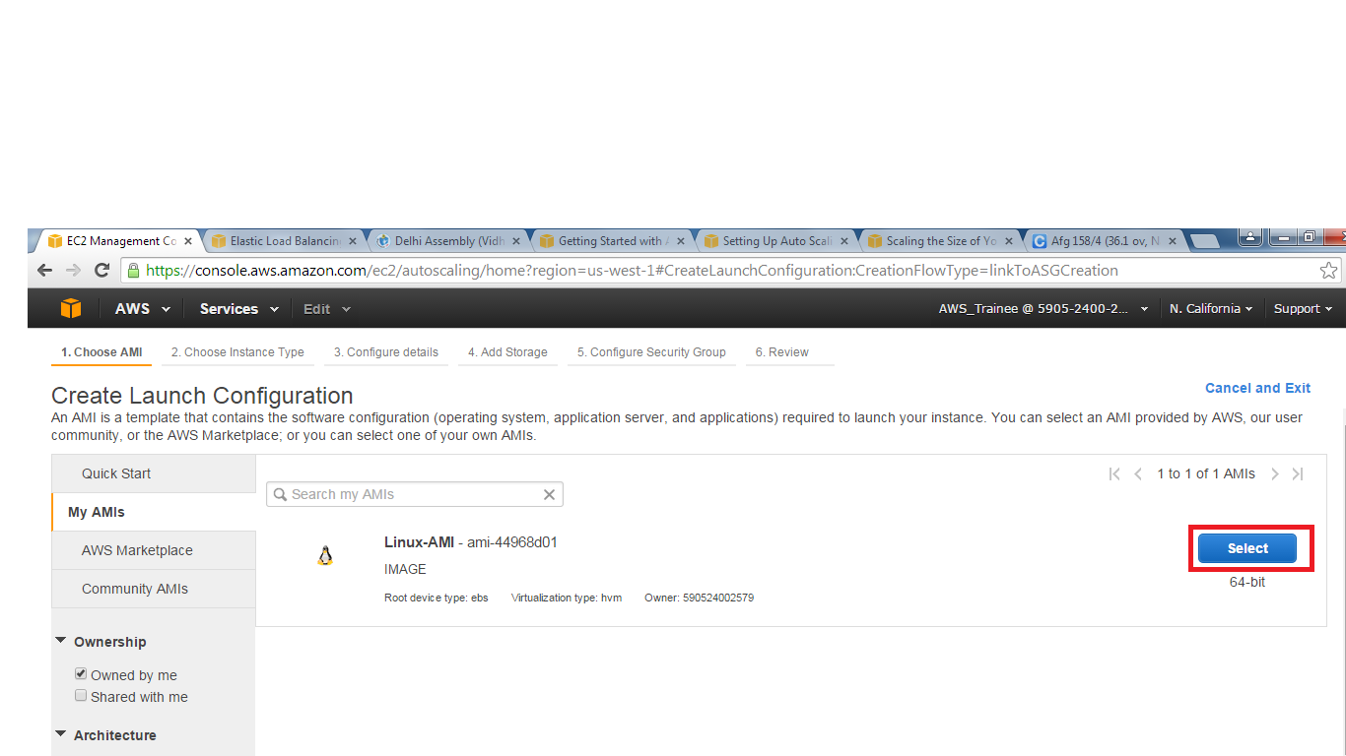

8. Next we have to select the type of instance which we want to use for creating the instance and click configur details
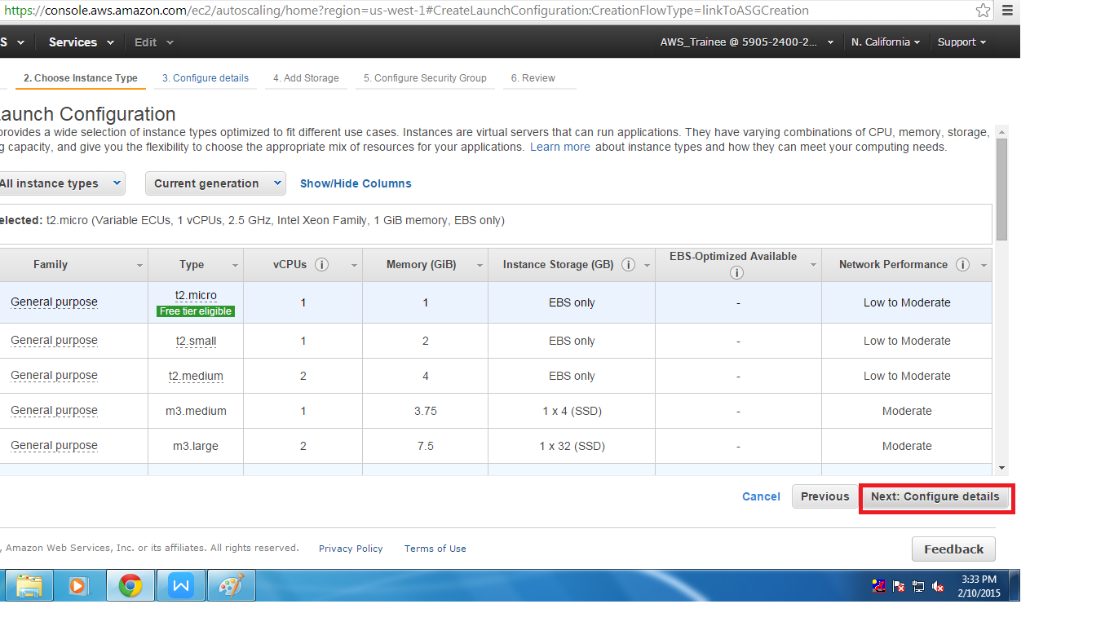
9. In this page we should give a name to launch configuration and click on skip to review

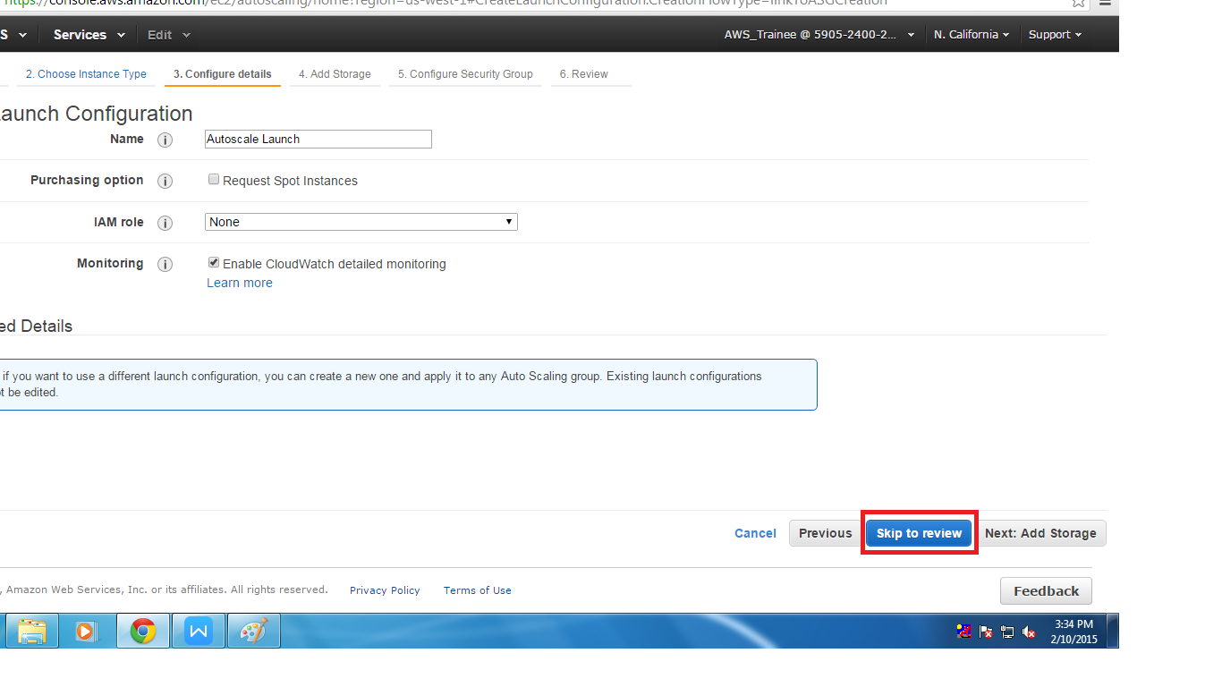

10. In this page we can edit both storage and security groups
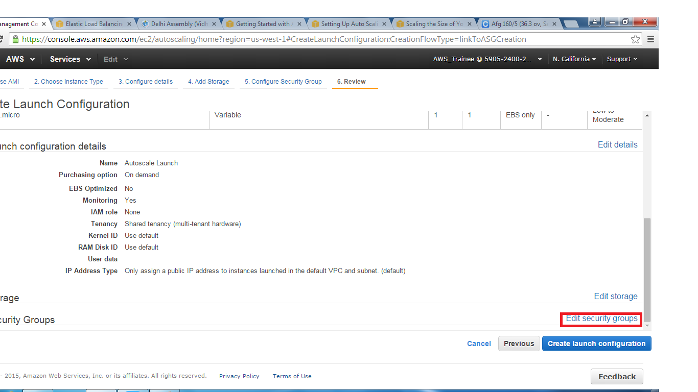
if we want to edit the security group here we can create new one or either existing one can be used. And than select review option.

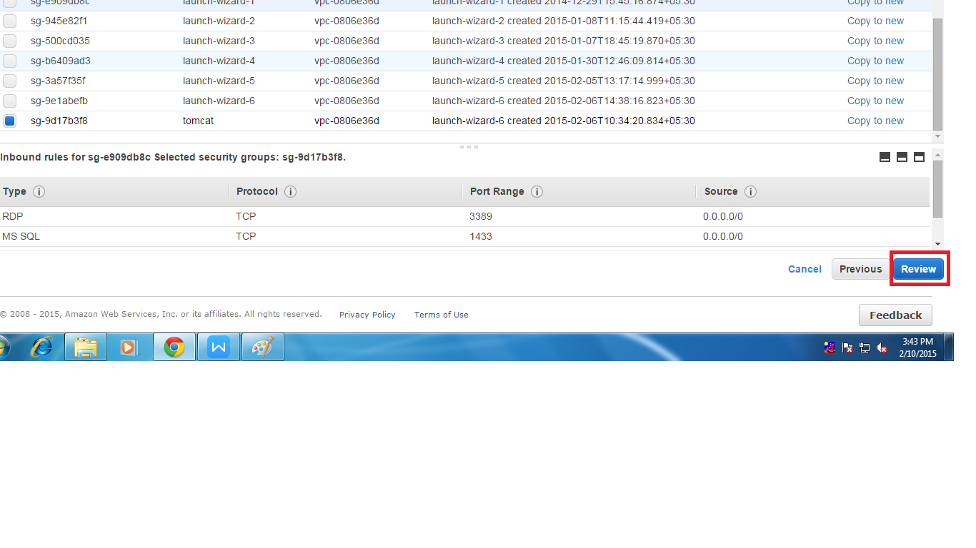

11. In next page we will find the total summary of the launch configuration after checking it than click on ccreate launch configuration

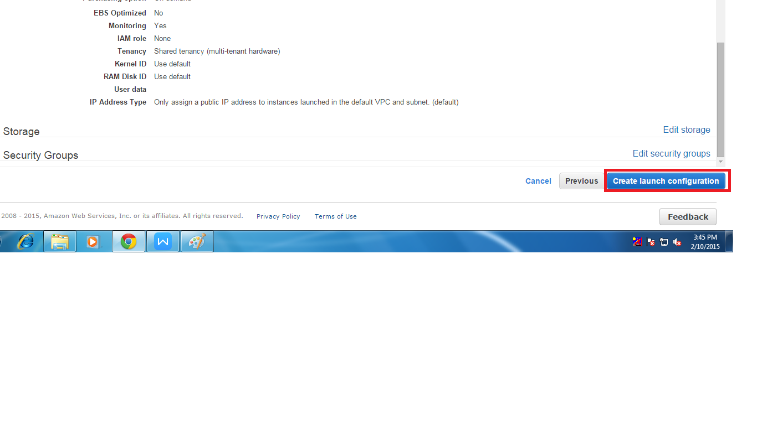
12. In this step we have to provide key for key we can use exiting one or creating new key
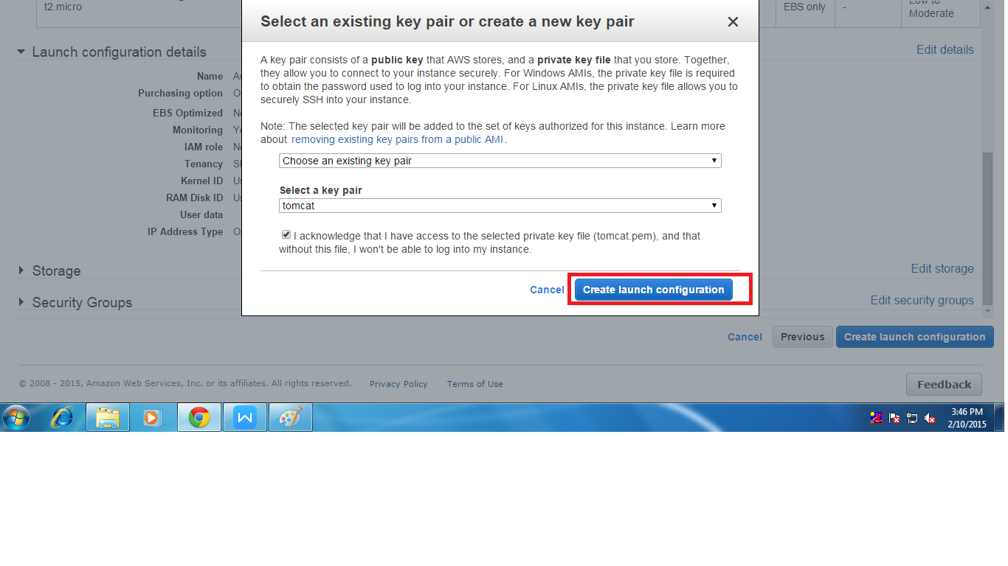

13. After that we have to create Auto scaling after creating launch config we will click on create auto scaling group her we want give some like name and subnet
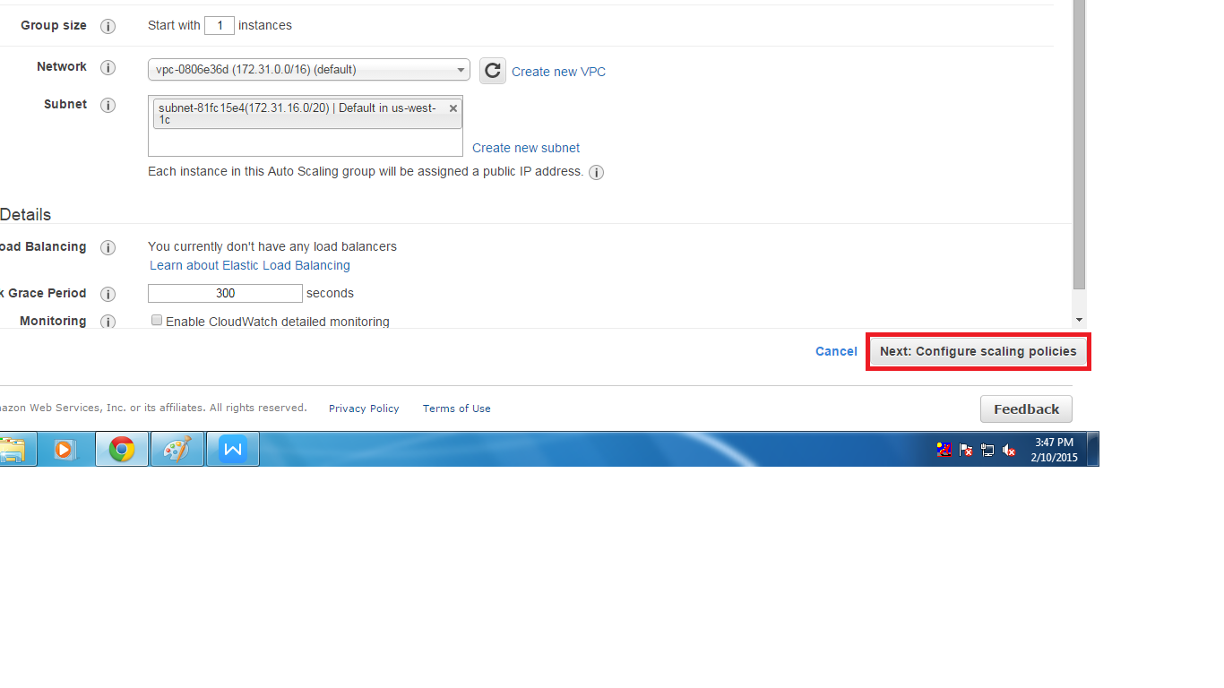
- After that we will find two option for creating auto scaling group there are
(i) Keep this group at inital size
(ii) Use scaling policies to adjust the capacity of this group
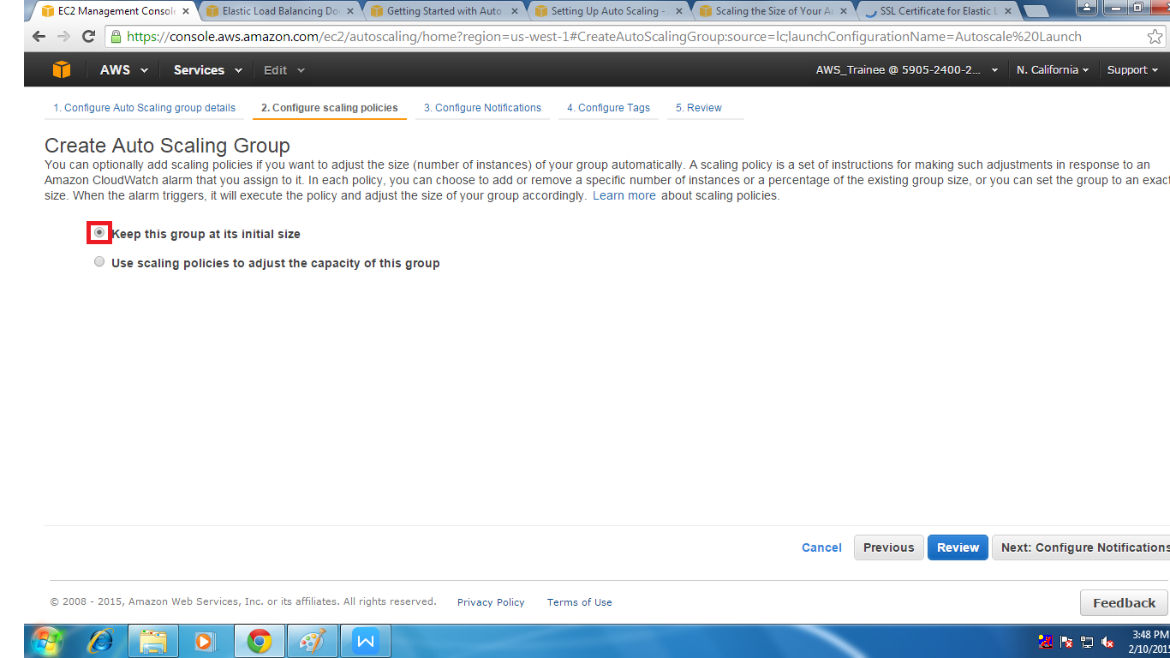

14. After checking the second option .We have to give Increase group size and decreases group size in the we have to create Alarms for adding and removing instances
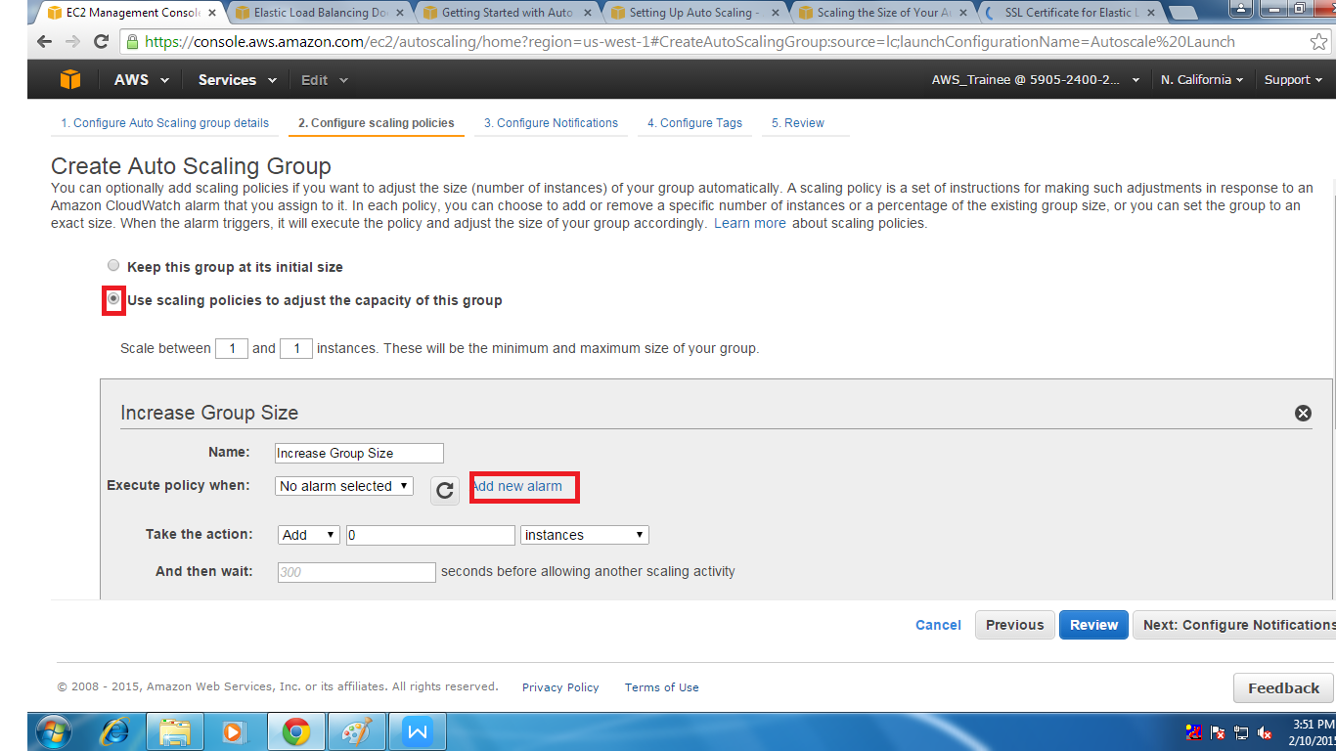

- When we select the create Alarm we find a small page where we have to some Credentials for both increasing and decreasing of group size there are.
(i) Maximum utilization of CPU for ex: 70% for it decreasing we have to use mini 40%
(ii) Uncheck the send notification to
(ii)How many instance should be add
for decreasing how many should removed
(iv)In how much time it should be added
for decreasing in how much time it shold remove
And click on create Alarm.
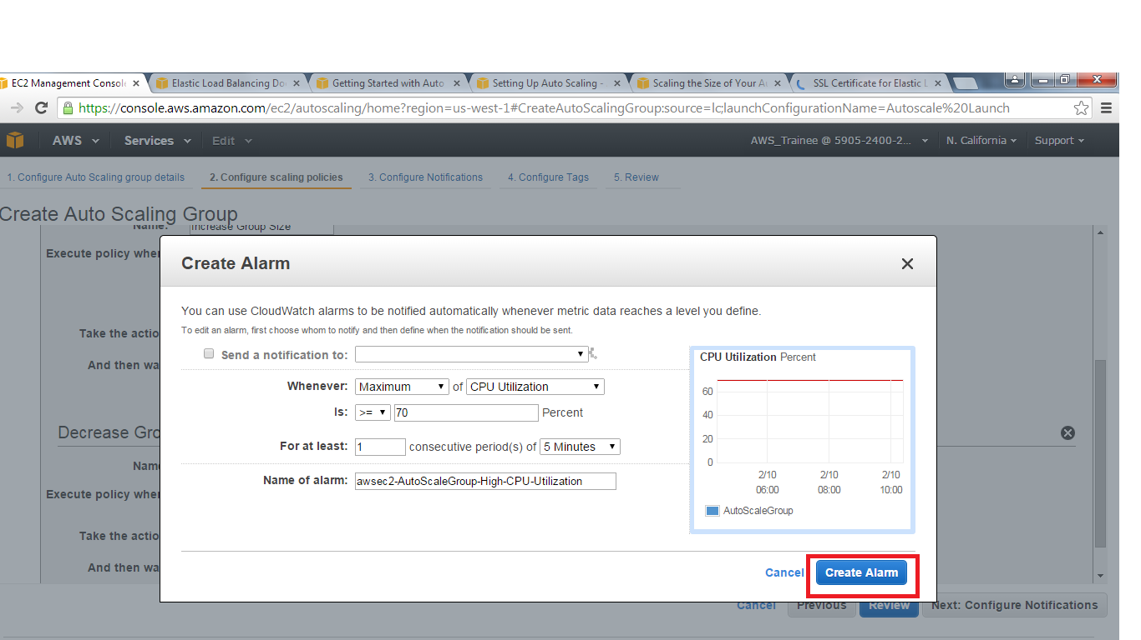

16. In increasing and Decreasing we have to set the action and time for allowing another scaling activity . And click on configuration Notification.

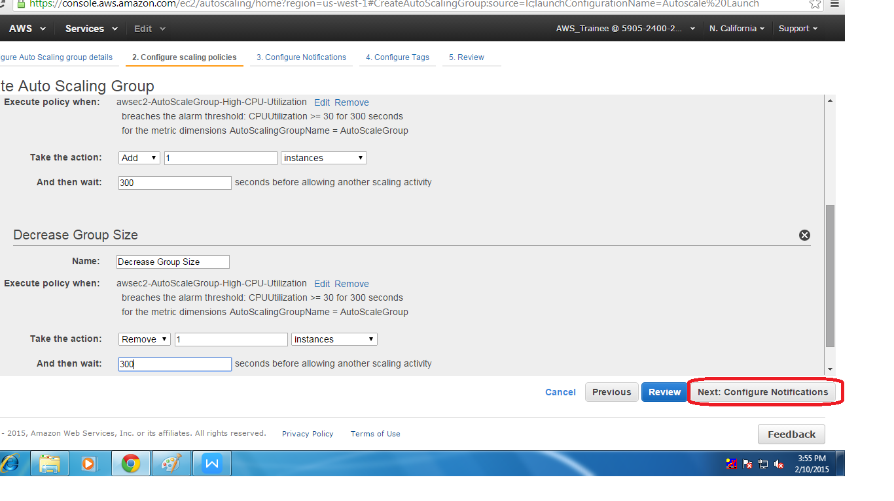

17. After that we can see the page of SNS notification if we had SNS notification than it show to us .Other wish it will show error.

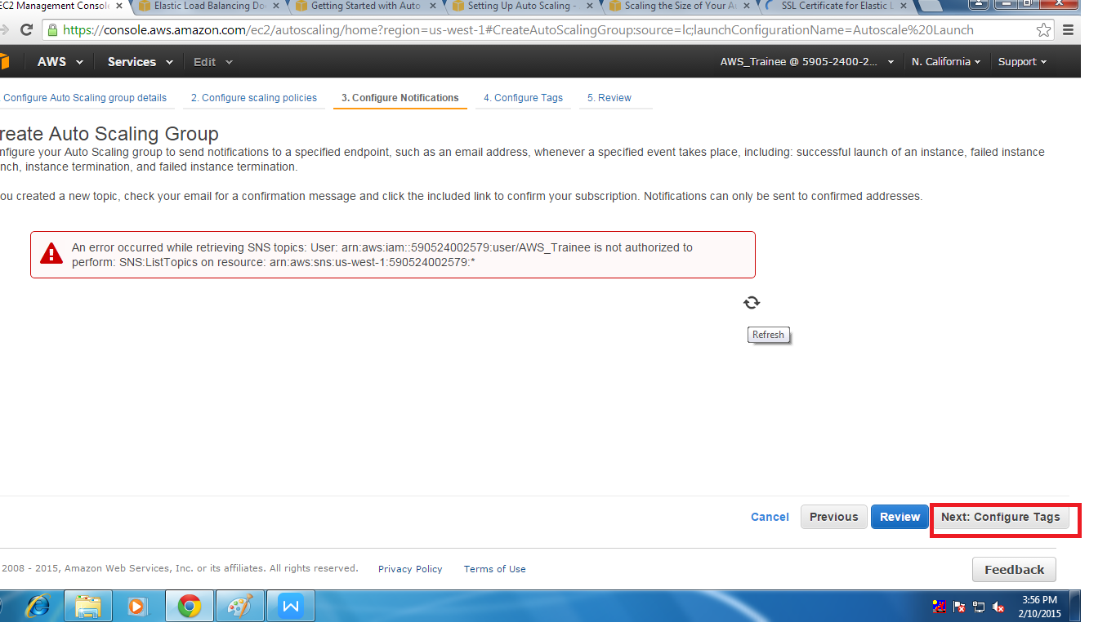

18. At last we have to configure the tag of the auto scaling group that me name to the auto scaling group
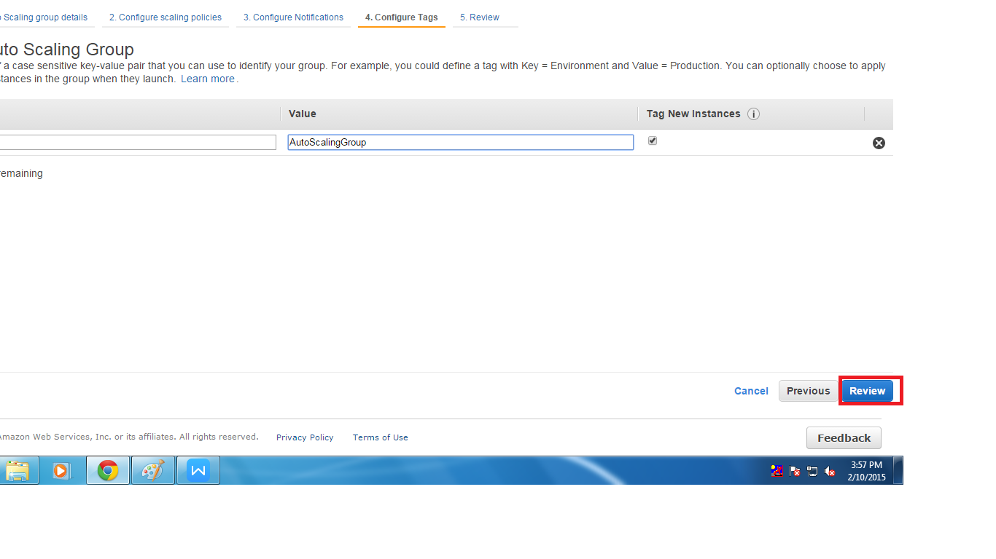

At last we can see the summary of the auto scaling group and click on creat auto scaling group . .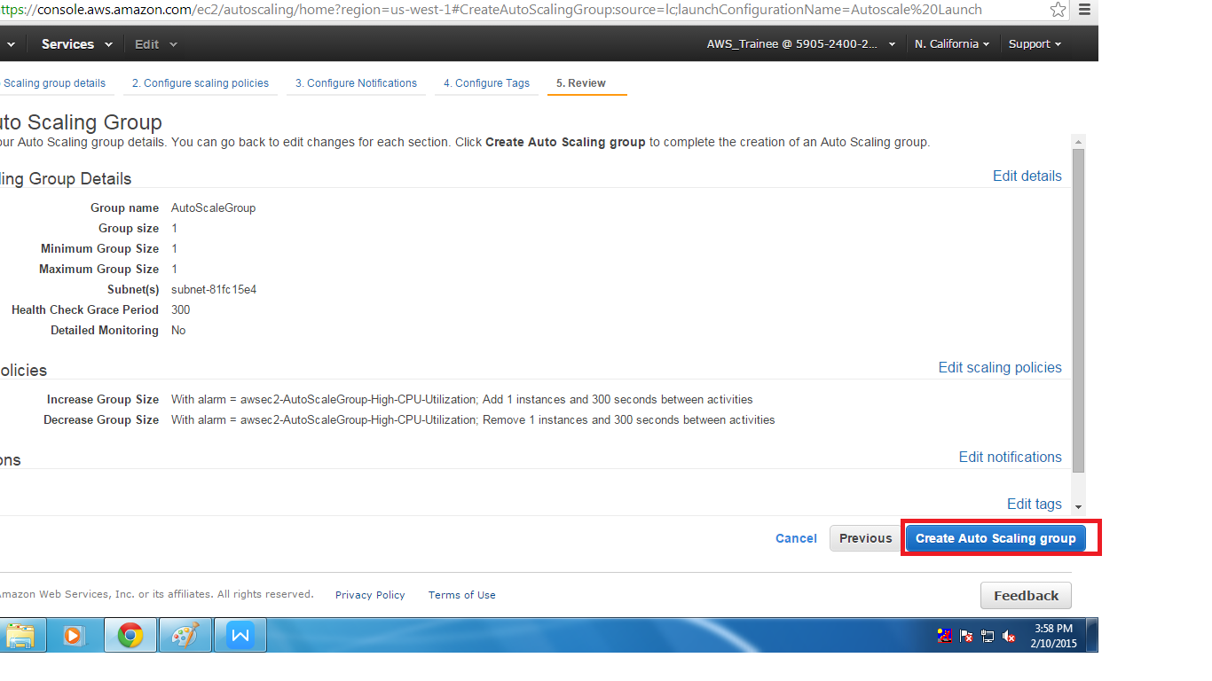

20. After creating auto scaling group we can see whether auto scaling group is working are not
